555 Timer.

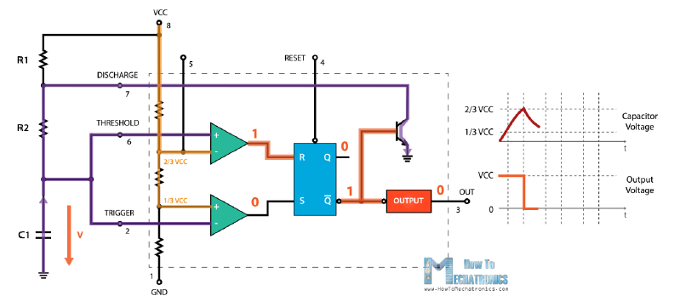

$$T_{on}=0.693*\left(R_{1}+R_{2}\right)*C_{1}$$

$$T_{off}=0.693*R_{2}*C_{1}$$

$$T_{total}=T_{on}+T_{off}=0.693*\left(R_{1}+2R_{2}\right)*C_{1}$$

$$f=\frac{1}{T_{total}}=\frac{1}{0.693*\left(R_{1}+2R_{2}\right)*C_{1}}$$

$$D=\frac{T_{on}}{T_{total}}=\frac{\left(R_{1}+R_{2}\right)}{\left(R_{1}+2R_{2}\right)}$$

We need a duty cycle between 0.2 and 0.8. Thus, by rearranging the design we get:

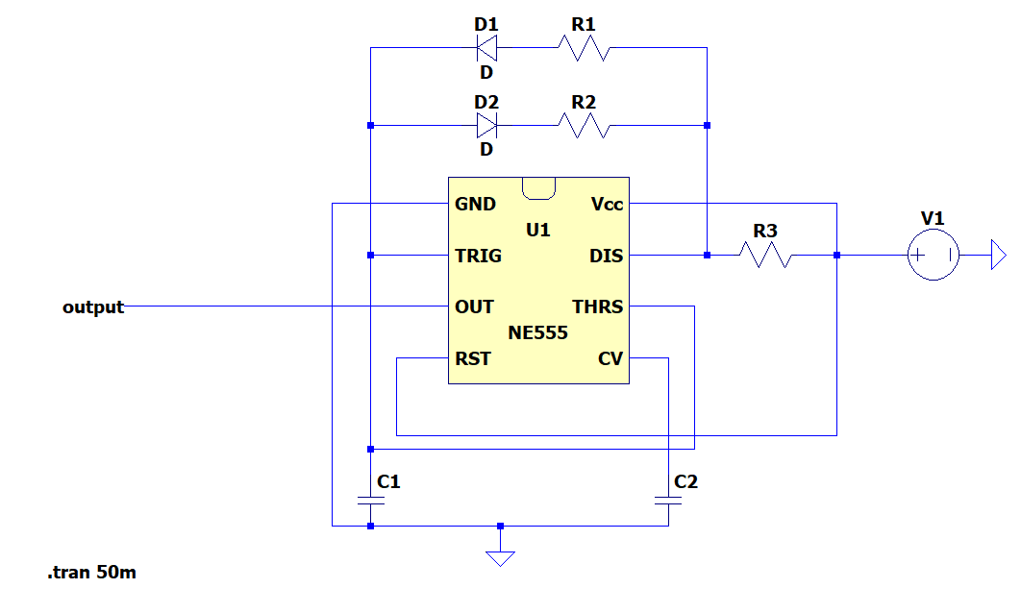

Adding two diodes to the system allows us to get wide range in duty cycle.

$$T_{on}=0.693*\left(R_{1}+R_{3}\right)*C_{1}$$

$$T_{total}=T_{on}+T_{off}=0.693*\left(R_{1}+R_{2}+R_{3}\right)*C_{1}$$

$$f=\frac{1}{T_{total}}$$

$$D=\frac{T_{on}}{T_{total}}=\frac{\left(R_{1}+R_{3}\right)}{\left(R_{1}+R_{2}+R_{3}\right)}$$

For D=0.2,

$$\frac{\left(R_{1}+R_{3}\right)}{\left(R_{1}+R_{2}+R_{3}\right)}=0.2$$

$$5*\left(R_{1}+R_{3}\right)=\left(R_{1}+R_{2}+R_{3}\right)$$

$$4*\left(R_{1}+R_{3}\right)= R_{2}$$

$$f_{D=0.2}=\frac{1}{0.693*5*\left(R_{1}+R_{3}\right)*C_{1}}$$

For D=0.8,

$$\frac{\left(R_{1}+R_{3}\right)}{\left(R_{1}+R_{2}+R_{3}\right)}=0.8$$

$$5*\left(R_{1}+R_{3}\right)=4*\left(R_{1}+R_{2}+R_{3}\right)$$

$$\frac{\left(R_{1}+R_{3}\right)}{4}= R_{2}$$

$$f_{D=0.8}=\frac{1}{0.693*\frac{5}{4}*\left(R_{1}+R_{3}\right)*C_{1}}$$

Hence,

$${4*f}_{D=0.2}=f_{D=0.8}$$

Choosing $R_{1}=R_{3}=1kΩ$, $R_{2}$ = 500Ω - 8kΩ variable resistor is needed to get Duty Cycle between 0.2 and 0.8. Since operating at higher frequencies cause higher switching losses, the pulse frequencies should be obtained around 1 kHz which will give us 0.22 µC capacitance value so that

$f_{D=0.2}=656 Hz$, and $f_{D=0.8}=2.62 kHz$. The simulation results for D = 0.2 and D = 0.8 are shown in figure 1 and 2.

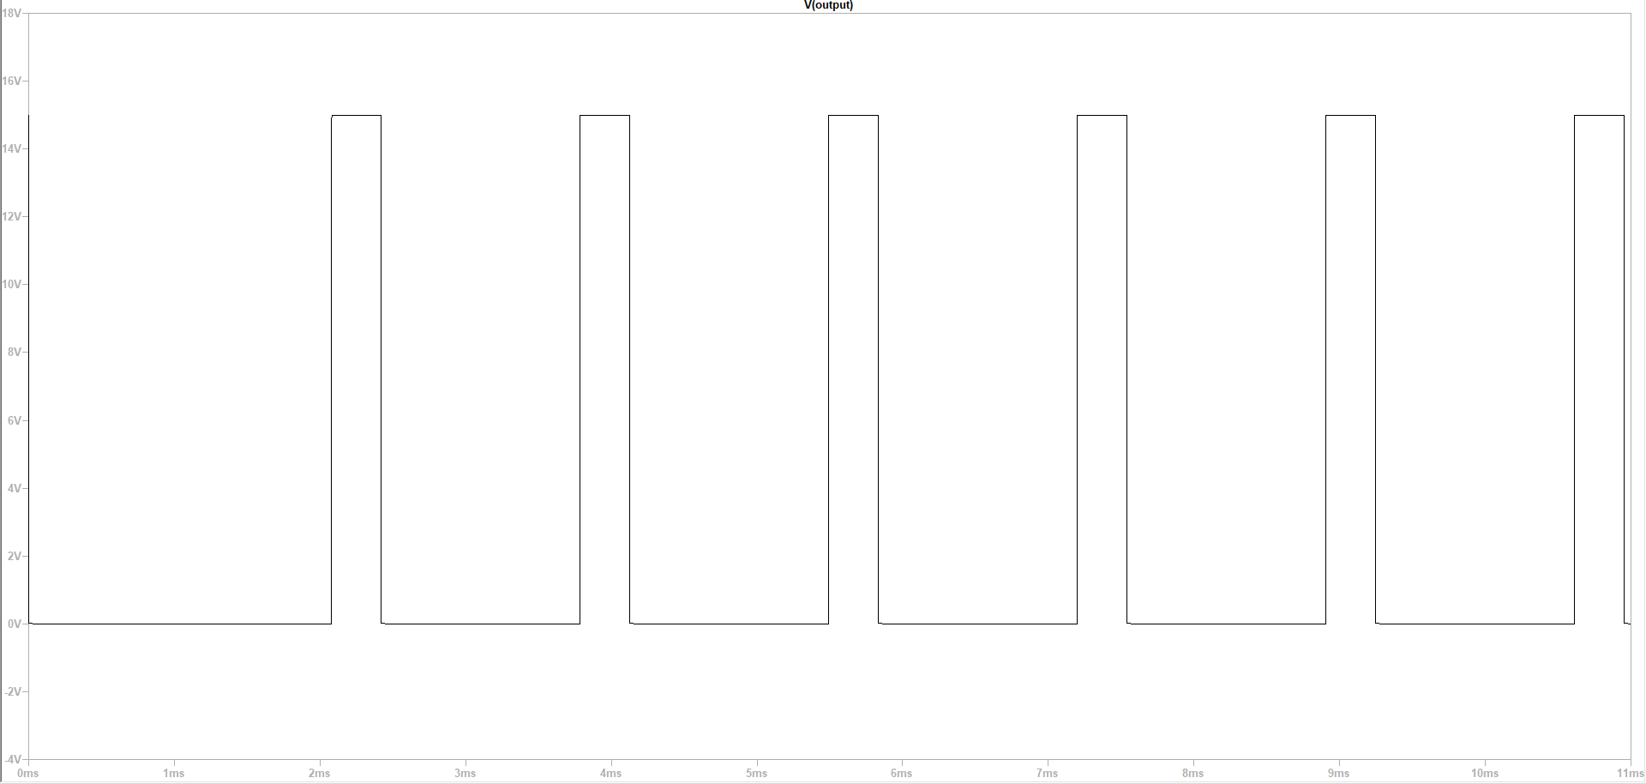

Figure Output of 555Timer for D=0.2

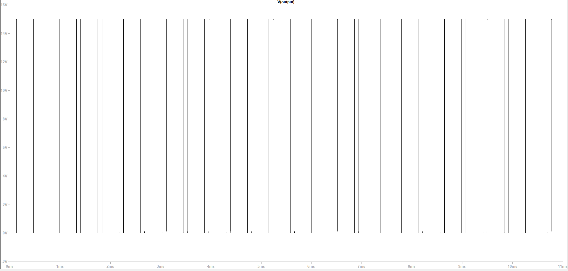

Figure Output of 555Timer for D=0.8